MAS TRM 2021 Compliance for Log360
Automate MAS TRM 2021 compliance and fortify cybersecurity resilience for financial institutions.
Region: Singapore, International | Type: Financial Services, Industry Standard, Incident Management | Category: Compliance | Pricing: Free

Overview
The MAS TRM 2021 compliance extension in Log360 helps organizations meet the MAS Technology Risk Management Guidelines (Jan 2021 Revision), mandating stronger cyber resilience, CISO appointment, and expanded board responsibilities for all MAS-regulated financial institutions by providing centralized log management, advanced threat detection, and audit reporting. The platform supports MAS TRM 2021 requirements for board governance, CISO oversight, cyber resilience, access control, privileged access, network security, endpoint protection, SOC monitoring, incident response, supply chain risk, and API security controls.
For Board and Senior Management Technology Governance, Log360 provides comprehensive governance audit reports across all IT systems to support board-level technology risk reviews and demonstrate ongoing governance accountability to MAS. To address CISO Appointment and Information Security Leadership, the platform consolidates security events from all sources into a unified platform, giving the CISO the centralized visibility needed to manage and report on the security posture. The extension also supports Technology Risk Assessment and Framework by providing capabilities that correlates cross-source security events to identify and assess technology risks in real time, supporting ongoing risk treatment evidence and regulatory documentation requirements.

Key Features
- Access Control and Identity Lifecycle Management: Log360 tracks AD user provisioning, Windows logon events, Unix access, and MFA authentication to enforce access control compliance and detect unauthorized access attempts.
- Privileged Access Controls and Activity Monitoring: Log360 monitors Unix SUDO commands, Windows administrator events, and AD role management to detect unauthorized privileged access and enforce dual-control obligations.
- Cyber Resilience and System Availability: Log360 monitors backup job completion, system events, and infrastructure health reports to validate and evidence the cyber resilience posture.
- Network Security and Perimeter Defense: Log360 tracks network device configuration changes, firewall rule updates, attack reports, and security events to enforce network perimeter controls across the financial institution's infrastructure.

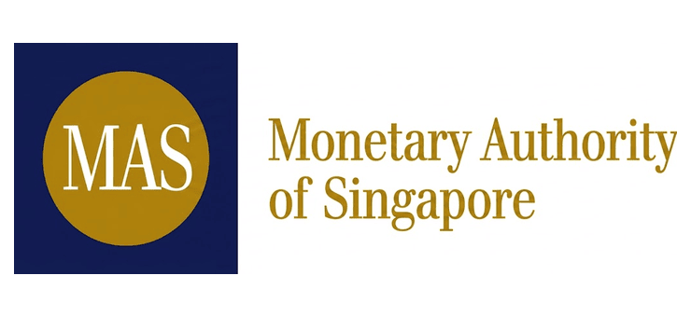
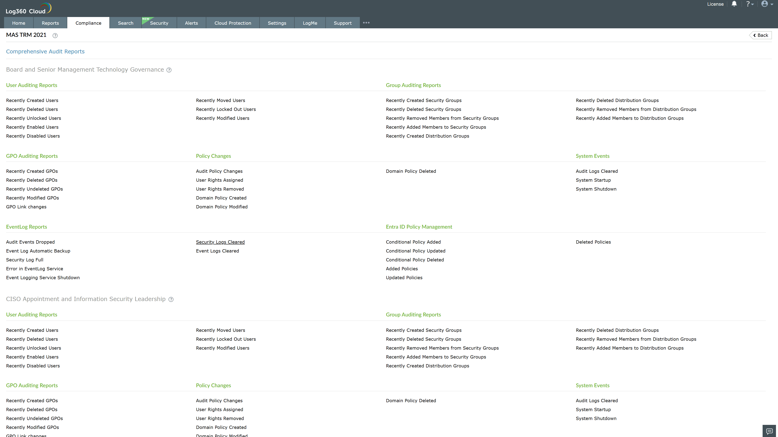
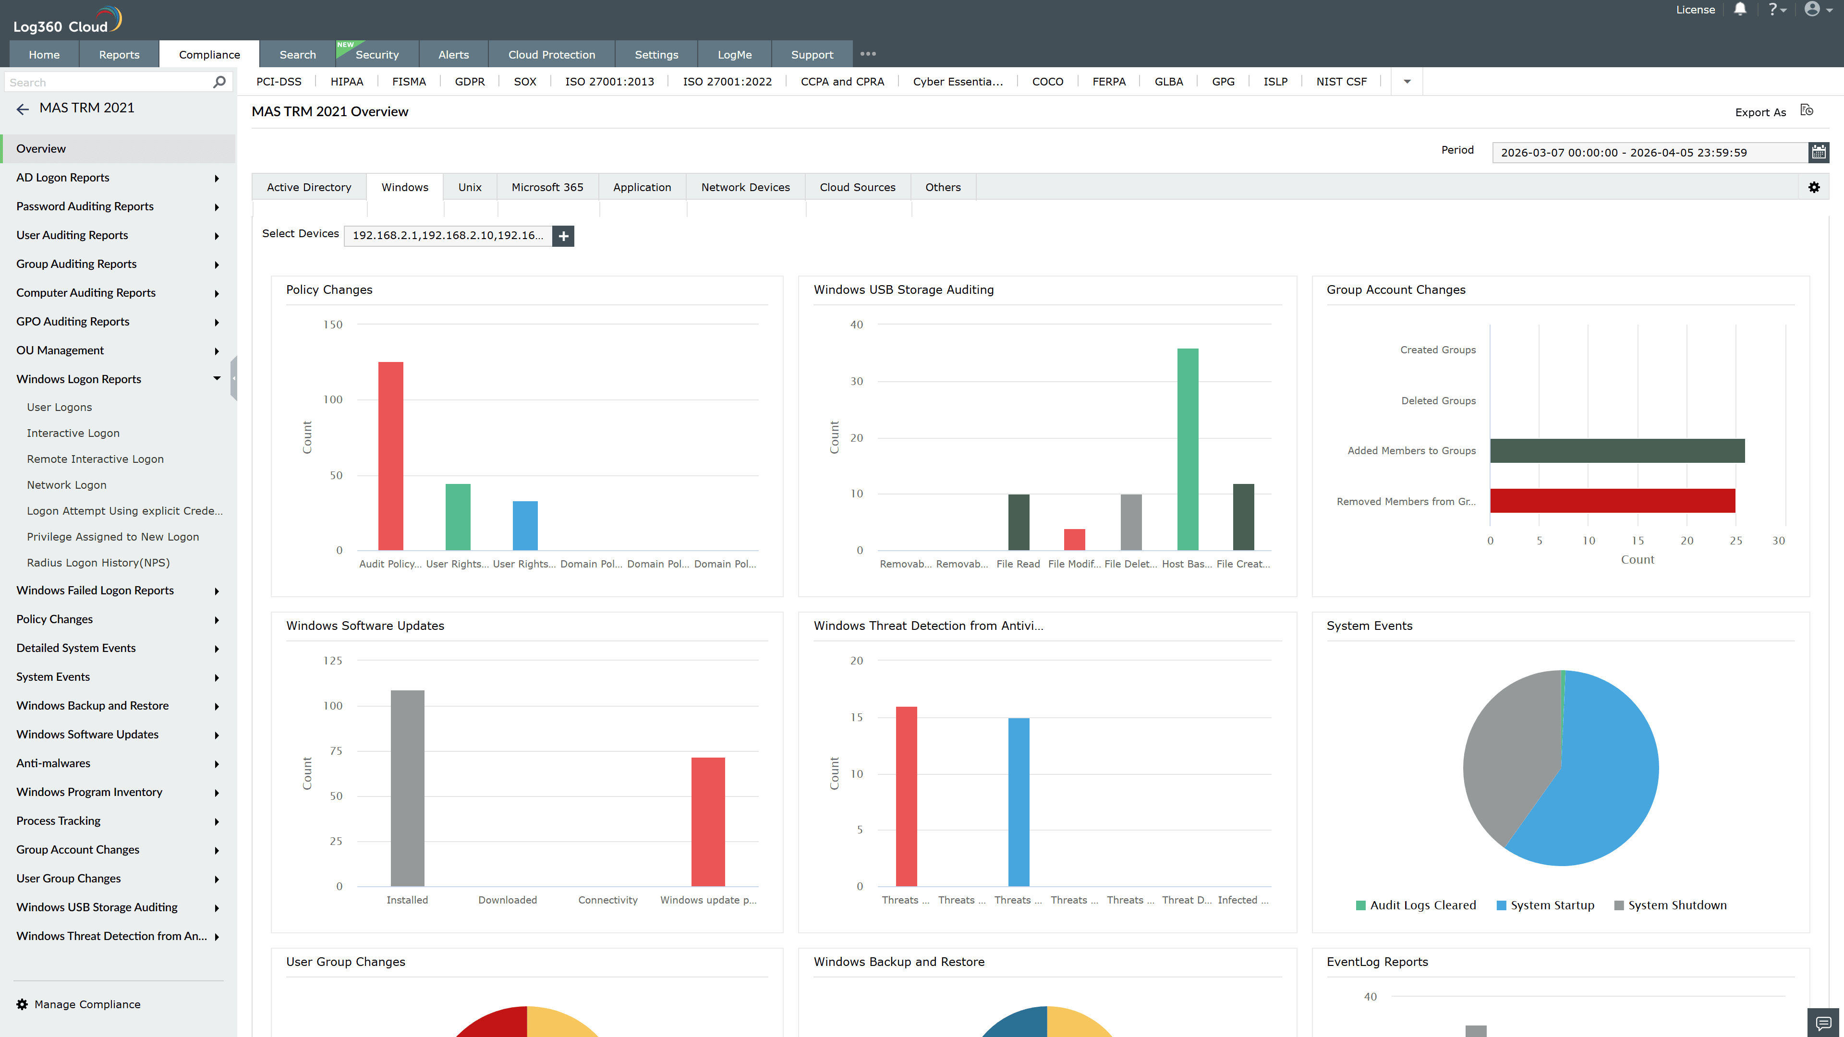
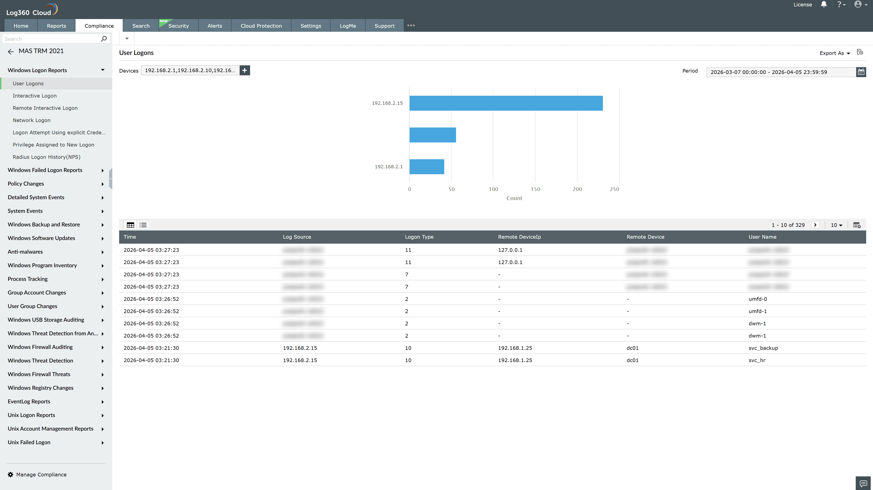
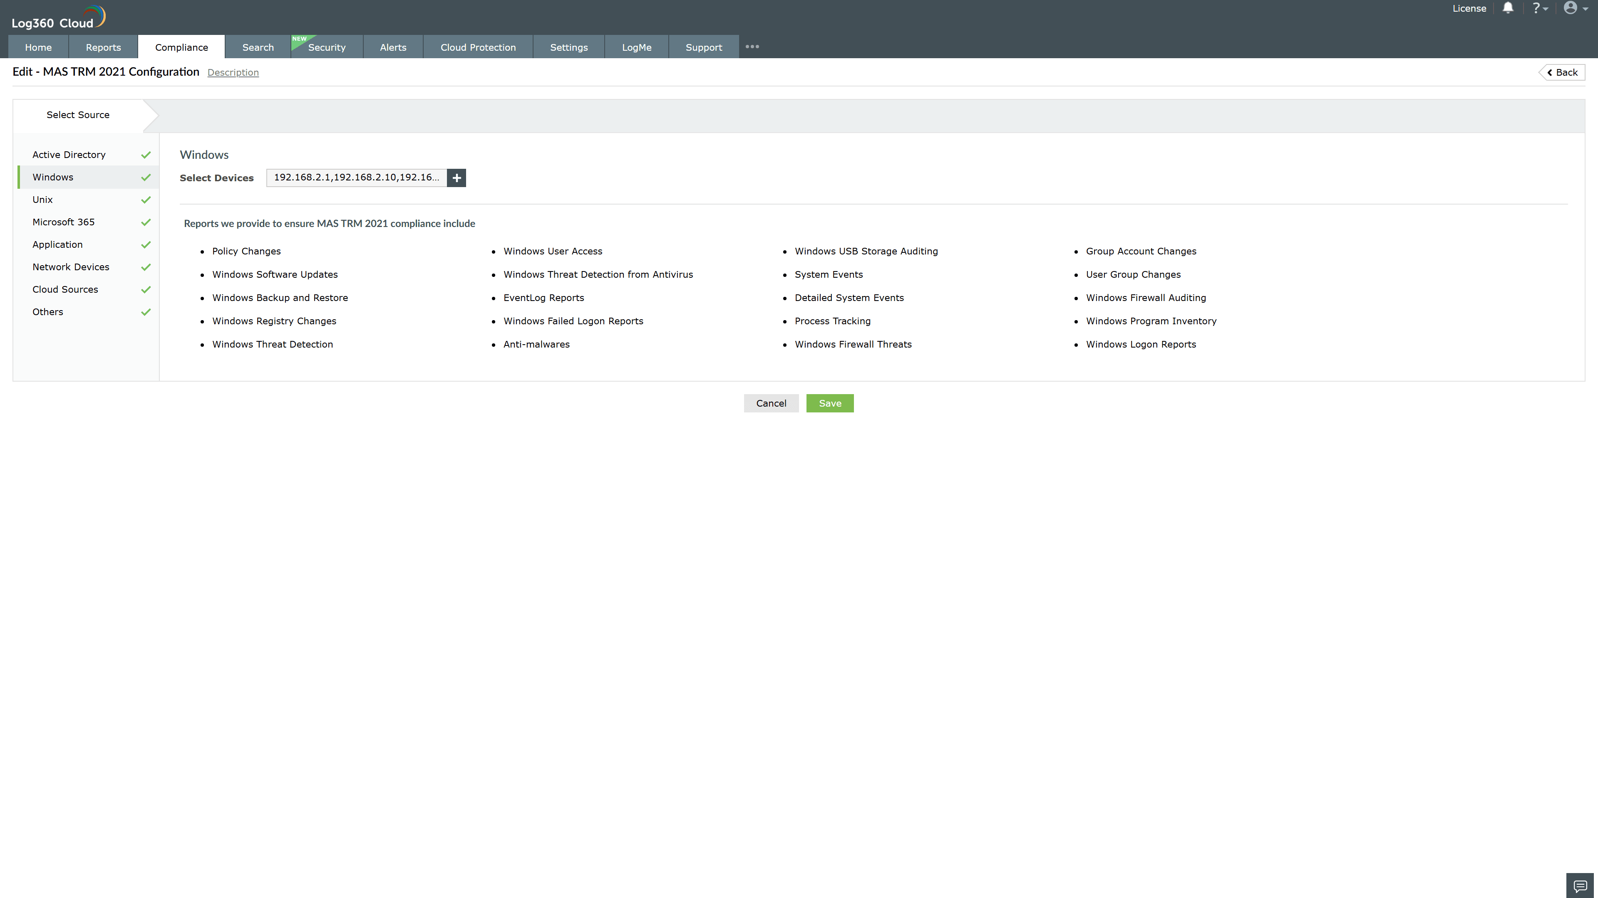
Valid Submission : Yes
Supported Editions : Free, Basic, Standard, Professional, MSSP
Help Document : https://www.manageengine.com/log-management/help/integrations/compliance-extensions.html
Help Video : Not provided
Tags : Log360, Compliance, Privacy monitoring, Data privacy, Regulatory compliance
Supported DCs : US, IN, JP, CA, AU, UK and EU
Privacy Policy:
Terms of Service:
Release Notes:
Predefined reports for the MAS TRM 2021.

